Name: Badal Prabhakar Wanjari

Branch: Computer Technology

Section: B

Semester: 3rd

Roll No. 140

Reg. No. 20011045



Practical - 10

**Aim:** Study of Pandas dataframe and implement dataframe related operations.

Programs:

**Converting data into dataFrame**

Program:

import pandas as pd

data = {"Roll No":[101, 102, 103, 104, 105], "Name":["Rahul", "Rajesh", "Raju", "Radha", "Raj"]}

df = pd.DataFrame(data)

print(df)

Output:

|  |
| --- |
| Roll No Name  0 101 Rahul  1 102 Rajesh  2 103 Raju  3 104 Radha  4 105 Raj |

Screenshot:

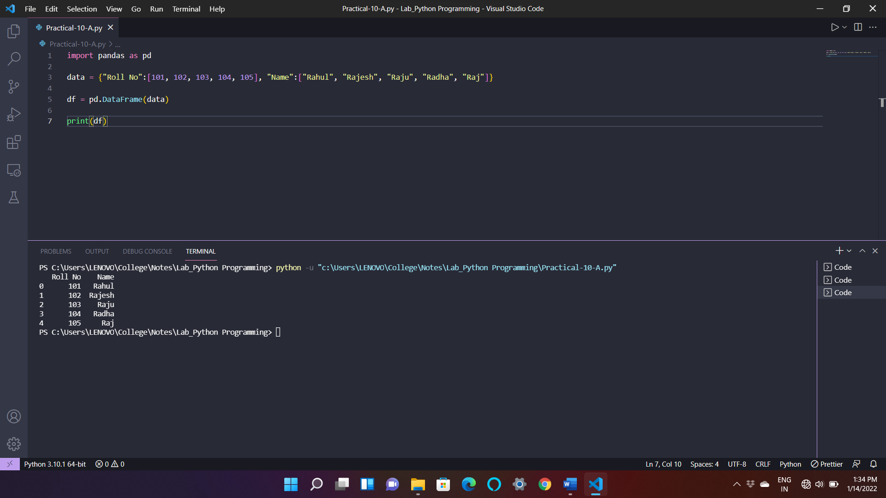

**Inserting Row in dataFrame:**

Program:

|  |
| --- |
| import pandas as pd  data = {"Roll No":[101, 102, 103, 104, 105], "Name":["Rahul", "Rajesh", "Raju", "Radha", "Raj"]}  Marks = [100, 99, 97, 67, 87]  df = pd.DataFrame(data)  df.insert(2, "Marks", Marks)  print(df) |

Output:

|  |
| --- |
| Roll No Name Marks  0 101 Rahul 100  1 102 Rajesh 99  2 103 Raju 97  3 104 Radha 67  4 105 Raj 87 |

Screenshot:

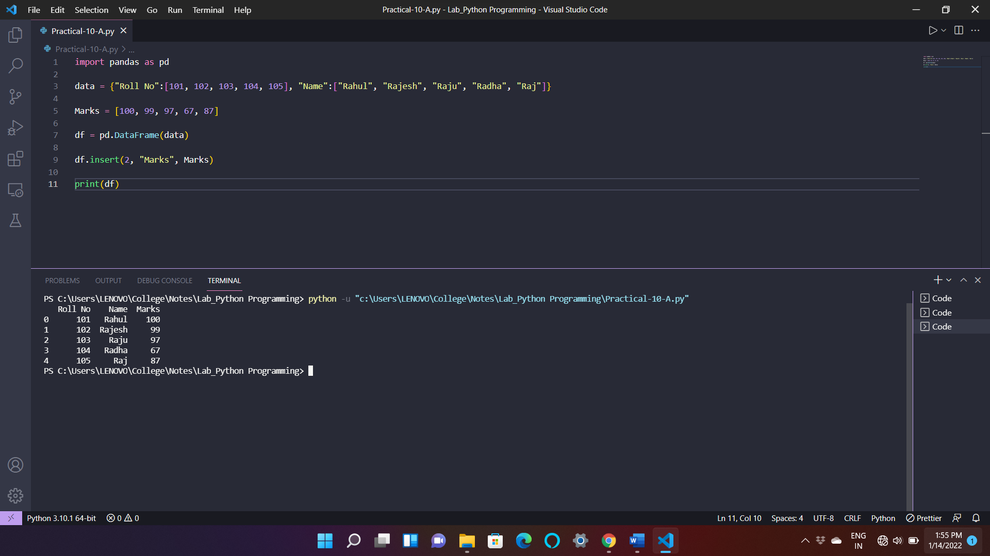

**Deleting Column from DataFrame:**

Program:

|  |
| --- |
| import pandas as pd  data = {"Roll No":[101, 102, 103, 104, 105], "Name":["Rahul", "Rajesh", "Raju", "Radha", "Raj"], "Marks" : [100, 99, 97, 67, 87]}  df = pd.DataFrame(data)  df = df.drop(['Name'], *axis* = 1)  print(df) |

Output:

|  |
| --- |
| Roll No Marks  0 101 100  1 102 99  2 103 97  3 104 67  4 105 87 |

Screenshot:

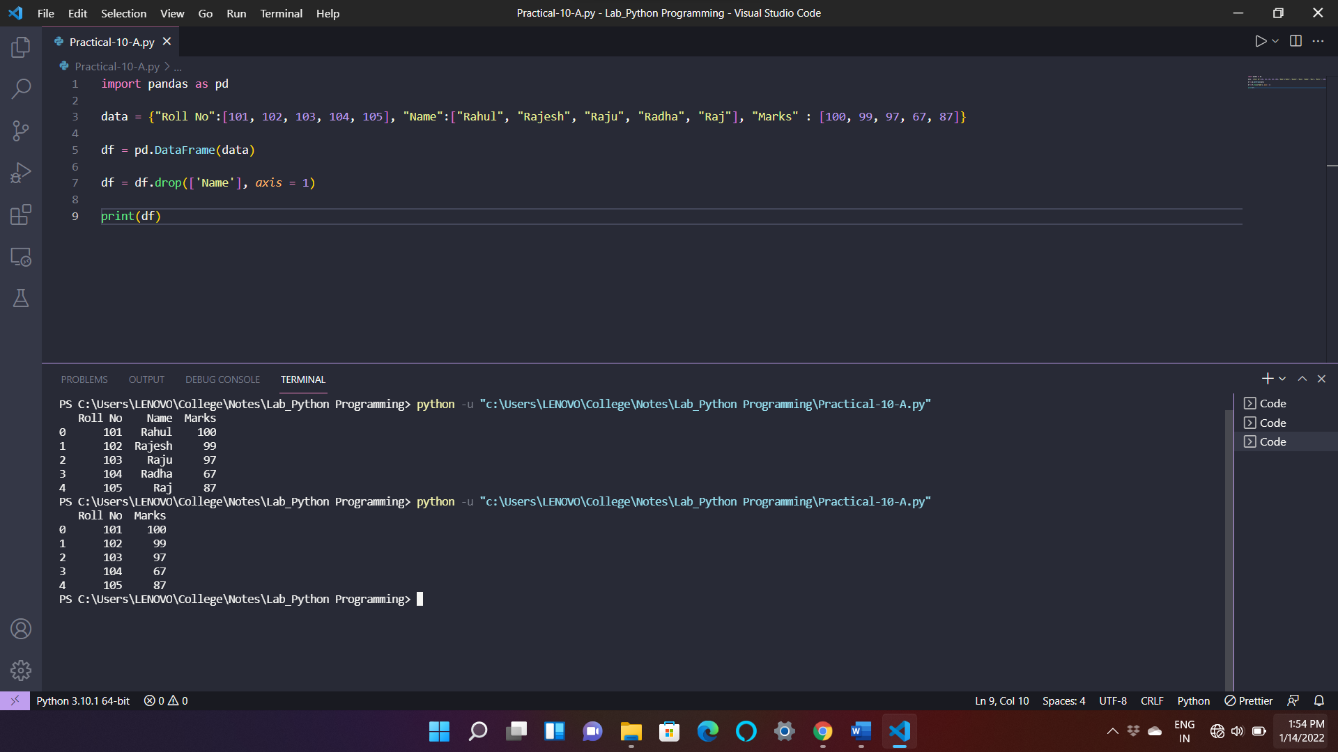

Result: By studying pandas library in Python, I have successfully completed Practical-10.